----------------------------------------------------------------------
Design of Automatic Cooling Fan
----------------------------------------------------------------------
An Electronic Project
Index
Subjects Page No.

Introduction 3
Theory
Comparator 4
Relay 5
Regulated Power Supply 9
Design Consideration
Circuit Diagram 11
Component Used 11
Alternative Components 12
Notes on Components 12
PCB Layout 12
Block Diagram & Operations
Block Diagram 13
Circuit operation 13
Data Sheet
741 op-amp 14
Conclusion
Application 16
Scope 17
Acknowledgement 17
Reference 17



The project entitled “Automatic Cooling Fan” is totally based on electronic transducer and logical circuits.

The temperature of a place changes all throughout the day. During the night or evening, the temperature decreases and during midday, the temperature increases at a high rate causing human to perspire.

The automatic cooling fan is a good idea for a room to cool it whenever the temperature rises above a certain level. No need to switch it on or off. It will automatically turn itself on when temperature rises and cools the environment of the room. Then it automatically switches itself off. Again it waits for the temperature to rise.

It can be used within an AC for good quality temperature stability. The idea is very simple. The total system is a closed loop control unit. There is an electronic transducer NTC (negative temperature coefficient) which senses the temperature. There is also a comparator acting as a decision maker, which takes two inputs, one from reference and other from the sensor and compares the two resistance to decide whether to start the fan or not. When temperature goes high, resistance of (NTC) is lower than the reference and it takes the decision to start the cooling fan. The fan cools the environment. As the temperature goes below reference, resistance of sensor goes higher than reference. Now comparator switches off the fan until temperature rises.

Comparators

Besides being used as amplifiers, filters and oscillators op-amps are also used as comparators, detectors, limiters, etc. A comparator, as its name implies, compares a signal voltage on one input with a known voltage called the reference voltage on the other input. In its simplest form, it is nothing more than an open-loop op-amp with two analog inputs and a digital output; the output may be (+) or (-) saturation voltage, depending on which input is larger. Comparators are used in circuits such as digital interfacing, Schmitt triggers, discriminators, voltage level detectors and oscillators.

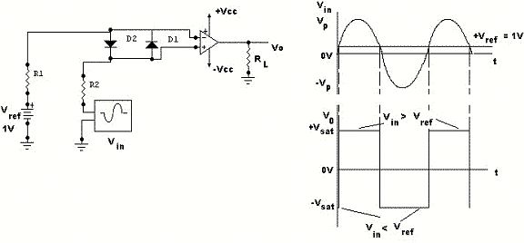

Figure shows an op-amp used as a comparator. A fixed reference voltage Vref of 1V is applied to the
(-) input and the time-varying signal Vin is applied to the (+) input. When Vin is less than Vref, the output voltage is at –Vsat (= -Vcc) because the voltage at the (-) input is higher than that at the (+) input. On the other hand, when Vin is greater than Vref, the (+) input becomes positive with respect to the (-) input, and Vo goes to +Vsat (=+Vcc). Thus Vo changes from one saturation level to another whenever Vin=Vref. The diodes protect the op-amp from damage due to excessive input voltage.
Relays

In designing the “Auto-Fan, for automatic temperature control” we have come across the relay that happens to be the most important part of our circuit. Here we discuss about relays in general but to be more specific the FGR (or the force guided relay) otherwise better known as the electro-magneto mechanical relay.

The FGR
Force guidance in a relay means that the contacts in a contact set must be mechanically linked together so that it is impossible for the NO (Normally Open) Make contacts and the NC (Normally Closed) Break contacts to be closed at the same time. There must be a 0.5mm minimum air gap between open contacts for the entire service life of the relay, even in the case of a failure. The force guidance of the relay contacts must always be preserved even in the event of any malfunction.

Applications
The safest way to turn off a power driven machine to protect human life, the environment or expensive materials is to employ safety-evaluating devices, which use force guided relays. Relays contain many parts that are subject to dynamic, electrical or thermal wear. In order to assure safe function, especially in the case of a failure, appropriate controls are built into the circuits of safety devices.
For instance, one force guided relay can be used to check the condition of another force guided relay or a number of them. If they are in the proper state, they energize and turn off the first relay- this provides the fail-safe or redundant feature necessary for safe operation of any machinery. The force-guided relay is the one component in a safety circuit that enables that circuit to provide redundant and fail-safe operation.

FGR’s are used in equipping control systems for: | More Applications:
Elevators and escalators  Cranes  Door and gate drive systems  Printing and textile machinery  Robots  Stamping machines  Medical equipment  Cutting machines  Railroad and subway signaling | Monitoring devices  Emergency stop modules  Safety door controls  Two-hand operating devices  Pressure mat controls  Light barriers and curtains  Speed controls  Din-rail safety modules

These relays consist of a non-movable part fixed to the frame and a movable part attached to the frame with a spring. The motion of the latter is transnational.
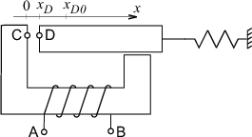
System Configuration

Sites of interaction
A, B ... electrical terminals
D ... mechanical terminal

System Parameters
R = 0.07 | [] | winding resistance
x_{D0} = 0.01 | [m] | free position of the movable iron part
N = 200 | [-] | number of turns
S = 10⁻⁴ | [m²] | cross-sectional area of magnetic material
k = 100 | [N/m] | spring stiffness
l = 0.1 | [m] | magnetical circuit length
₀ = 0.4 | [F/m] | permeability of vacuum
_{r} = 500 | [-] | relative permeability of material
m = 0.01 | [kg] | mass of the movable iron part
b_{s} = 0.2 | [N.s/m] | friction factor
V = 0.1 | [V] | input voltage

Response Curves
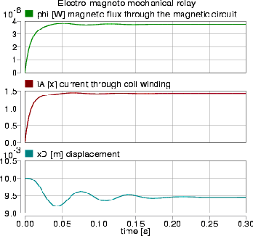
Pre-Cautions
When SCR's are used to operate relays with half-wave rectified power source to make release easy, almost all operations and releases could occur at the same point in the waveform. In the case of heavy loads such as heater loads of temperature controllers, the opening and closing of contacts can occur at any point in the waveform of the control.
Thus, contact life can vary greatly. A thorough check of the controlled equipment should be made to determine true operation condition.
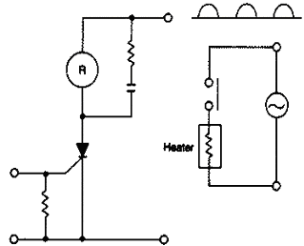
Temperature Control Circuit
In circuits in which the operating current is not turned ON or OFF completely but increases or decreases gradually, the operating time will be unstable or the snap action of the contacts will be weak. Contact life may be shortened due to arcing and the specified electrical life may be thus shortened.

When DC load is turned ON and OFF by contacts:

- DC ON-OFF capacity is less than AC ON-OFF capacity. For example, the AC rating of 5 x 105 operations for a specific set of contacts is 10 A at 125 V but the equivalent life for DC is 0.5 A at 125 V.
- Transposition may cause contact corrosion and pitting, reducing service life.
- Metallic parts may corrode abnormally, reducing service life.

Forward & reverse rotation of motor
If the rotation of a motor is reversed while it is running, arc is generated across contacts of the relay, which ionizes air around the contacts, resulting in arc short-circuit of power source circuit and its damage. Therefore, it is necessary to extinguish arc completely, and then change over.
When changing over power source by the contacts of the relay, bridge accident due to heterogeneous power sources because of short changeover time as well as damage of contacts due to arc may occur.
It is desirable to form an interlock circuit in the control circuit comprising a push-button and a relay, and after turning on one power source, turn on the other power source.

Solid State Relay
Nowadays the SSRs (Solid State Relay) are being used as an alternative for various other kinds of relays. The main reasons being

- Long Life Expectancy
Solid-state relays use electronic instead of mechanical devices for load switching while providing a life cycle expectancy of approximately 100,000 energized hours or 11.4 years. This reduces product replacement and downtime.

- Low Maintenance
There are no moving parts or contacts to wear out or be affected by vibration and shock. Maintenance cost, parts replacement, and downtime are reduced drastically, if not eliminated altogether.

- Reduced Power Costs
The solid-state relay typically requires 25 times less power than electromechanical relays and also generates less heat. This means the panel can typically be smaller, reducing panel space requirements.
Protection of SSRs against:
- Heat
Adequate heat sinking, including consideration of air temperature and flow, is essential to the proper operation of a solid-state relay (SSR). It is necessary that the user provide an effective means of removing heat from the SSR package. The importance of using a proper heat sink cannot be overstressed, since it directly affects the maximum usable load current and/or maximum allowable ambient temperature. Lack of attention to this detail can result in improper switching (lockup) or even total destruction of the SSR. Up to 90% of the problems with SSRs are directly related to heat. All solid-state relays develop heat as a result of a forward voltage drop through the junction of the output device. Beyond a point, heat will cause a lowering (or de-rating) of the load current that can be handled by the SSR. "Heatsinks" are used to create a method of removing heat away from the relay, thus allowing higher current operation. With loads of less than 4 amperes, cooling by free flowing convection or forced air currents around the unit is usually sufficient. Loads greater than 4 Amps will require heat sinks.

Electrical Noise
SSRs generally do not fail due to electrical noise, unless they happen to mistrigger during a point in the line cycle when an excessively high current surge might occur. Usually, a malfunction due to noise is only temporary, such as turning on when the SSR should be off, and vice-versa.
By its very nature, noise is difficult to define, being generated by the randomness of contact bounce and arcing motor commentators, etc. Noise, more properly defined as Electromagnetic Interference (EMI), affects the SSR by feeding signals into the sensitive parts of the circuit, such as the SCR.
- Surge current
There are very few completely surge less SSR loads. Next to improper heatsinking, surge current is one of the most common causes of SSR failure. Overstress of this type can also
seriously impair the life of the SSR. Therefore, in a new application, it would be wise to carefully examine the surge characteristic of the load and then select a device that can adequately handle the inrush as well as the steady state condition, while also meeting the lifetime requirements.
In addition to the actual surge ratings given for SSR's, the rate of rise of surge current (di/dt) is also a factor in AC thyristor types. Exceeding its value may result in destruction of the device. As a guide, the amperes-per-microsecond (di/dt) withstand capabilities are typically in the order of their single cycle surge ratings.
The highest surge current rating of an SSR is typically 10 times the steady-state RMS value, and it is given as the maximum peak current for one line cycle. It should be noted that a surge of this magnitude is allowable only 100 times during the SSR's lifetime. Furthermore, control of conduction may be momentarily lost due to a surge. This means that it may not be possible to turn off the SSR by removal of control power both during and immediately after the surge. The output thyristor must regain its blocking capability and the junction temperature allowed to return to its steady state value before reapplication of the surge current, which may take several seconds.
It should be noted that the preceding cautionary notes apply only to the extreme limits where the SSR should not be designed to operate anyway.
Generally, DC SSRs do not have an over current surge capability, since the output transistors are usually rated for continuous operation at their maximum capacity. The tendency is for the DC SSR to cut off (current limit), thus impeding the flow of excessive current. However, the resultant over dissipation may destroy the relay if the surge is prolonged.

Fusing
Fast, "Semiconductor Fuses" are the only reliable way to protect SSR's. They are also referred to as current-limiting fuses, providing extremely fast opening while restricting let-through current far below the fault current that could destroy the semiconductor. This type of fuse tends to be expensive, but it does provide a means of fully protecting SSRs against high current overloads where survival of the SSR is of prime importance.
Regulated Power Supply

A regulated DC voltage source is obtained from a AC voltage source is easily by rectification. AC voltage is of 230V r.m.s. is easily available. This voltage is step downed by a transformer. Then rectified by diodes. If a center taped transformer is used only two diode is sufficient for full wave-rectification. If transformer is not a center taped bridge rectifier is used. After rectification the voltage is DC but contains high ripple. A LC or RC filter is used at the output to filter the high ripple voltage. Now this voltage can be used for DC supply. But this DC source is not regulated means if the input AC voltage changes output also changes. To get a regulated output zener diode regulation and Voltage Regulator may be used.

Voltage regulators come in integrated circuits in a variety of ranges. Regulators are of four types

- Fixed output voltage regulators: positive or negative output voltage
- Adjustable output voltage regulators: positive or negative output voltage
- Switching regulators
- Special regulators

We use 7806 and 7812 for positive fixed Regulated power supply.

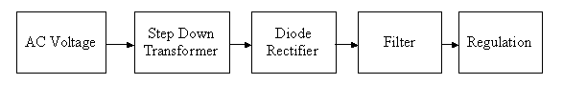
Block Diagram

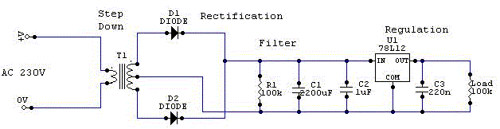Circuit Diagram
Automatic Cooling Fan Circuit

Circuit Diagram
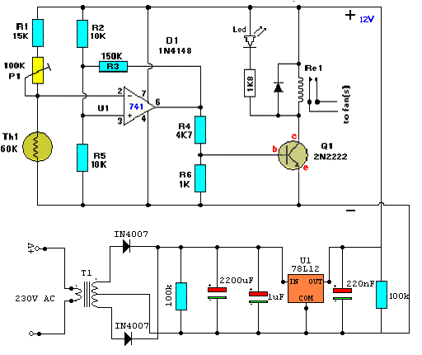
Components Used
Part | Description | Notes
IC1 | LM741 Op-Amp | NE741,µA741, etc
Q1 | 2N2222A transistor | Any Power Transistor
D1 | 1N4148 Diode | 1N4001, or others
Th1 | 60k Thermistor | KC003T in prototype
Re1 | 12v ,150Ω Relay | RS is 1A
R1 | 15k ,¼ W,5% resistor | Brown-green-orange
R2,R5 | 10k, ¼ W,5% resistor | Brown-black-orange
R3 | 150k, ¼ W,5% resistor | Brown-green-yellow
R4 | 4k7, ¼ W,5% resistor | Yellow-purple-red
R6 | 1k ,¼ W,5% resistor | Brown-black-red
P1 | 100k Preset Pot | Cermet multi-turn
Diode | 1N4007 or 1N4001 | 1A max
Resistor | 100k ,½W,5% resistor | Quantity 2
Capacitor | 2200uF,1uF,220nF | Electrolytic

Alternative Components

Q1 | = | 2N3053, 2N3904, NTE123A, ECG123A, NTE128, ECG128, etc.
D1 | = | 1N4001, NTE519, ECG519, NTE116, etc.
Th1 | = | Thermistor, 10k -100k. Used 60k in prototype.
Re1 | = | Relay. A reed relay will also work.
Th1, the 60k thermistor, is a standard type, tablet or thingy rectangular in shape. Almost any type will work. Different models from 10k-60k will work fine. Only modification in trimmer is needed. Replace the trimmer pot with suitable value. Another name for the thermistor is ‘NTC’. NTC stands for ‘Negative temperature Co-efficient’. Which means surrounding temperature decreases the resistance of this thermistor decreases.
P1 is a regular Preset potentiometer and adjusts a wide range of temperature for this circuit. We use a regular type Preset but a regular Bourns trimmer potentiometer will work for a bit finer adjustment.
R1 is a ‘security’ resistor just in case the trimmer pot P1 is adjusted all the way to ‘0’ ohms. At which time the thermistor would get full 12Volts and may burnt out.
R3 is the feedback resistor. The op-amp is working in inverting mode. If we would not put any feedback the circuit may become oscillatory or unstable. R3 makes a negative feedback, prevents oscillation and makes operation of comparator stable.
Transistor Q1 can be a 2N2222(A), 2N3904, NTE123A, ECG123A, etc. Any power transistor will equally well. It acts only as a switch for the relay so almost any type will work, as long as it can provide the current needed to activate the relay’s coil.
D1, the 1N4148, acts as a spark arrestor when the contact of the relay opens and eliminates false triggering. When the relay coil is energized and suddenly voltage is taken off because of switching action of the transistor the current will reverse its flow because relay coil is an inductor. This reverse current will be passed through the diode. For handling more current for the relay we may use 1N4001.
Re1, Relay is 12V 150Ω, suitable for small applications. Maximum current handling capacity is near 1A. Any type of size and resistance will work equally well. Only 12V relay will work in the circuit.

The PCB
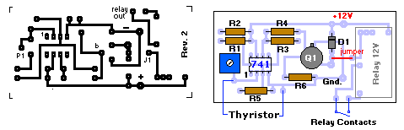

Circuit Operation

Operational Block Diagram

Temperature sensor
Reference Voltage
Voltage corresponding to Temperature
Comparator (Op Amp)
Signal Conditional circuit
Relay Switch
Motor Drive

The aim of the circuit is to sense the temperature of the air or a heat sink of power circuit and make decision, whether to start the cooling motor. There is a reference point for temperature. When temperature of air goes higher than that circuit will take a decision of turning on the fan or motor automatically.
Circuit of our project is a small closed loop control system. In this circuit there is comparator as decision maker, Thermistor as temperature sensor, DC Amplifier as a signal conditioning element and a relay as switch.
There are two in put in the comparator. We keep a reference voltage in non-inverting input as an equivalent of reference temperature and the output of the thermistor is given to the inverting input. The comparator or the op-amp is in the inverting mode of operation. In normal situation when temperature is less than reference, resistance of thermistor is quite higher (about 60k). There is higher voltage in inverting input than the non-inverting input. Obviously, op-amp will work in negative saturation. This will make DC amplifier or the transistor in cut-off region. No voltage will be there at the output. When temperature goes up the resistance of the thermistor goes down rapidly (drops down to 1k). The voltage across this sensor will rapidly decay below the reference voltage of the non-inverting input. Now, the op-amp will go to the positive saturation, resulting a high output. This output is fed to the power transistor. This transistor is acting as a power switch. When comparator output is in positive saturation, transistor gets a high base input and goes to hard saturation. This in turn, energized the relay coil making the DC motor switch on. The fan will now cool the environment (say a heat sink). As temperature falls down below reference, the resistance of thermistor again goes up (about 60k) and voltage builds up across it. The inverting input again goes high making op-amp in negating saturation i.e. switching off the relay and motor. The circuit waits till the temperature rise to works.
741 Datasheet

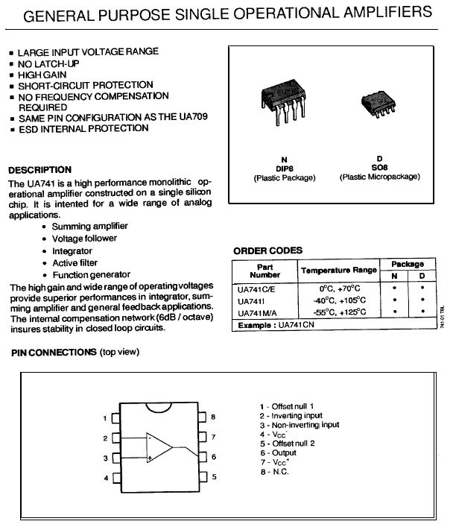
741 Datasheet
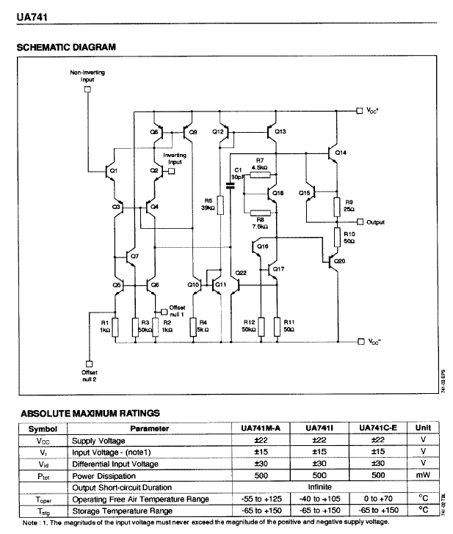
CONCLUSION

Design of Automatic Cooling Fan Applications

Automatic Cooling Fan in short Auto-Fan can be successfully used in variety of electronic equipments and gadgets. The reason behind its wide range of application is that the fan is fully automatized, the fan goes to on or off state depending on temperature variations.

It is a known fact that all electronic components and IC’s are all temperature sensitive. Thus to nullify the temperature effect so as to prevent thermal runaways in transistors, we have to use Auto-Fan as it works as a means of heat dissipation. Sometimes due to IC’s being extremely hot, that is if it is used for long hours, or it might happen that some inexperienced person may connect the pin of IC to a higher voltage power supply, then in that case excessive current will flow in a fraction of a second and the IC will burn out if there is no mechanism of controlling heat flow. Sometimes heat sink are used, but Auto-Fan has more advantage than heat sink as it requires circuitry of very small size and it has a small sized highly sensitive thermistor which makes its operation more efficient.

Chiefly Auto-Fan is used inside the processor (CPU) of every home PC. Also there are some PC’s that are used as direct digital controllers in various industries. Here Auto-Fan must be incorporated in these processors, for long running of these machines without any failure. This can be achieved by an Auto-Fan because when temperature rises above a rated value, the fan will automatically be on and will provide a means of air circulation.

Similarly Auto-Fan can also be used in Television set, in Function Generators and in CRO’s. Also with the Auto-Fan set you can attach a thermometer that will indicate the temperature variation, which is occurring inside the electronic equipment.

Scope of our project work

It was an exciting experience to manifest a useful instrument in our day-to-day life; the Auto-Fan inculcated a great scope for us to explore the potentialities of relays & comparators or in general the Operational Amplifiers. We have made a sincere attempt to make the work flawless, however in some cases it was short of our expectation., & after a lot of project sessions we have been able to make the Auto-Fan operate nearly flawlessly.

Acknowledgement
The project topic given to us is "Design of Automatic Cooling Fan". With our limited knowledge and the unlimited help lent to us by the faculty we have endeavored ourselves into the project. It is a pleasure to be grateful to our project guide Prof. S. Sen & all other respected faculty members of Netaji Subhash Engineering College & we also thank every other person who has helped us in a way or so.
Also this being a group-project every member of the group has contributed in their best possible way towards the final outcome.

Reference:

The necessary theories of this Project are collected from the following books listed below.

Electronic Material Processing – Anusua Kalavar.
Opamps and Linear Integrated Circuits- Ramakant A. Gayakward
Integrated Electronics – Jacob Millman & Christos C. Halkias
Basic Electronics—BoylSted & Nationalsky
A TEXT-BOOK OF ELECTRICAL TECHNOLOGY- B.L.THERAJA

